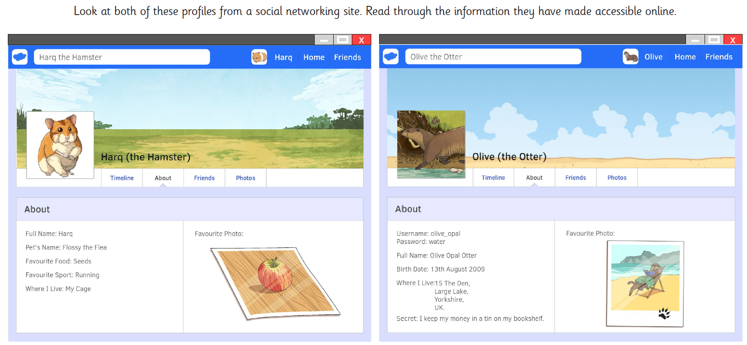
Tick the boxes | Harq the Hamster | Olive the Otter
1. Whose full name do you know?
2. Whose house could you find?
3. Whose birth date do you know?
4. Whose username and password do you know?
5. Who let out a secret on the Internet?
6. Which animal can you describe better from his or her photo?

